Medex Medical Center (C- Medex)

Software Requirements Document

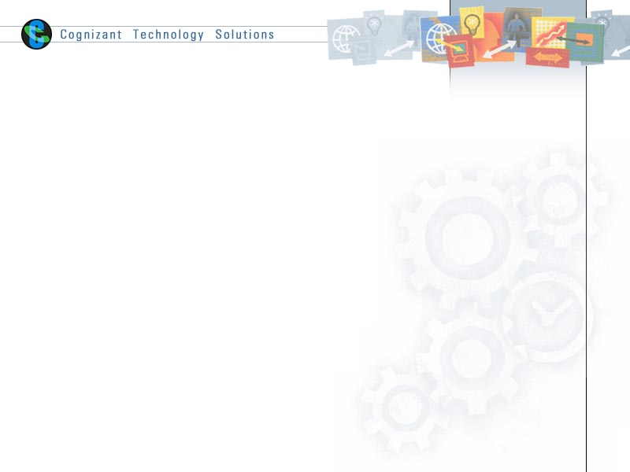

Table of Contents

1.0 Introduction 5

1.1 About this document 5

1.1.1 Purpose & Scope of the document 5

1.1.2 Intended Audience 5

1.2 About the Software System 5

1.2.1 Purpose 5

1.2.2 Scope of the system 5

1.2.3 System Perspective 6

1.2.4 System diagram 7

1.2.5 System Environment 7

1.2.6 User Characteristics 7

1.2.7 Impact of the System 8

1.2.8 Assumptions, Dependencies, Risks / Constraints 8

1.2.9 Software proposed 8

2.0 System Requirements 9

2.1 Functional Requirements 9

2.1.1 Home Module 9

2.1.2 Patient 10

2.1.2.1. Patient - Registration page 10

2.1.2.2. Patient - Login Page 11

2.1.2.3. Patient - Logged in page 12

2.1.2.4. Book Appointment Tab 13

2.1.2.5. View Appointments 14

2.1.2.6. Cancelation Appointment 15

2.1.3 Doctor 16

2.1.3.1. Check Appointments 16

2.1.3.2. Add Diagnosis Info 17

2.1.3.3. View All Appointment 18

2.1.4 Medex Admin 19

2.1.4.1. Report 19

2.1.5 About Us 20

2.1.5.1. Abous Us Tab 20

2.1.6 Contact Us 21

2.1.6.1. Contact Us Tab 21

2.2 Non functional Requirements 22

2.2.1 UI Requirements: Inn 22

2.2.2 Performance Requirements: Pnn 22

2.2.3 Installation, Deployment & Operational Requirements: Onn 22

2.2.4 Maintainability & Portability Requirements: MPnn 22

2.2.5 Security Requirements Snn: 22

2.2.6 Training Requirements (TRnn) 22

3.0 Make /Buy analysis 23

3.1 Reusable components 23

4.0 Annexure 23

5.0 Change Log 23

# Introduction

## About this document

### Purpose & Scope of the document

The purpose of the software requirements document is to systematically capture requirements for the project and the system to be developed. Both functional and non-functional requirements are captured in this document. It also serves as the input for the project scoping

The scope of this document is limited to addressing the requirements from a user, quality, and non-functional perspective. It is recommended that design aspects are not added in this document.

### Intended Audience

* *Project Team*
* *Customer(to sign-off this document)*

## About the Software System

### Purpose

C-Medex Medical Center would like to develop a website to automate & manage patient appointments booking.

### Scope of the system

The proposed system consists of three major modules i.e.

* + - **PATIENT**
    - **DOCTOR**
    - **MEDEX ADMIN**

1. The Scope of Patient module is to

* **Login:** Patient login
* **Register:** New Patinet registration
* **Patient**: This will capture information about Patient register as well as Patient details
* **Book a Doctor’s Appointment:** Patient can book an appointment with the Doctor for consultation along with date and time preferred, and also we have option to select the specialty to consult

1. The Scope of Doctor module is to

* **Check Appointments :** Doctor can check the appointment scheduled
  + **Add Diagnosis Info:** Doctor can add diagnosis details in form
  + **View All Patient Info:** Doctor can view the past appointment history details

1. The Scope of the **Medex Admin** module is to
   * **Reports:**  The Admin will have the options to generate the vise kind of reports giving summary details of patients & doctos

**Use Case Diagram**

Patient

<<Uses >>

Medex

Admin

<<Uses >>

<<Extends >>

<<Uses>>

### System Perspective

This is an independent system and should be implemented using Java architecture.

### System diagram

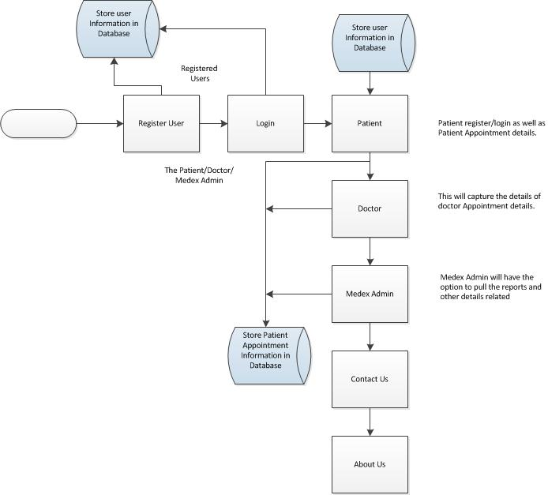

### System Environment

The Medex Medical Centers web site will be operated from the C-Medex server with parallel processor support.When a user connects to the Web Server, theWeb Server will interact with the Database after processing the business logic to transfer data to and from a database.

* Java/J2EE application deployment.
* My Sql database for data storage

### User Characteristics

The application should be user friendly; hence the user should not need any software and hardware knowledge. The user may be new to C-Medex products having never used them before.

### Impact of the System

This is a new product which is developed for internal users. Expected impact of the product is to automate existing manual processes in order to make them more efficient and cost effective.

### Assumptions, Dependencies, Risks / Constraints

### Software proposed

* Java and J2EE (Eclipse)
* My Sql

# System Requirements

## Functional Requirements

|  |  |
| --- | --- |
| Medex Medical Centers Ltd  Req-2.1.1 | Home Page |
| **Functional Requirements**  When the users enter to following link **http://localhost:9999/MedexMedicalCenter** in the browser, Home page appears which will have a short welcome message; a brief introduction to the purpose of the C-Medex, the user can choose appropriate options.  Medex Medical Centers super-specialty services where specialist care is effectively administered under one roof. At Medex Medical Centers Hospital, there is a continuous drive for quality in order to meet patients’ standards through quality healthcare delivery.  Under home page, we need below interface. | |
| **Home page Interface Requirements**   1. Home 2. Patient 3. Doctor 4. Medex Admin 5. About Us 6. Contact Us | |

### Home Module

### Patient

### Patient - Registration page

|  |  |
| --- | --- |
| Medex Medical Centers Ltd  Req-2.1.2.1 | Patient - Registration for free |
| **Functional Requirements**  When the patient/user clicked on the registration for free link, it should re-direct to registration for free form and the users/ patient need to fill some of the basic attributes/fields as mentioned below in requirement;  Login Id ,Password,First Name,Last Name,Age, Gender (Male or Female) ,Contact Number  E-mail , Address, Zip code, City  Any given point of time, the user can deselect all or can go to home page by the clicking home. | |
| **User Interface Requirements**   1. Login Id – System generates automatically the login id’s 2. Password – The user should able to provide the password with( Combination of at least one number, one lowercase, one uppercase letter and at least eight characters) 3. First Name - User should able to have option to enter first name in the text box 4. Last Name - User should able to have option to enter last name in the text box 5. Age – The user should able to enter the age 6. Gender (Male or Female) - Should have selection option to appropriate gender 7. Contact Number - Should have a options to enter the contact number 8. E-mail - The user should have an option to field to enter the e-mail 9. Address – The user should have an option to enter the address. 10. Zip code(Pre populated) - Zip code should automatically per populate 11. City(Pre populate) - City should automatically per populate 12. There should be 2 buttons i.e. Register, reset | |

### Patient - Login Page

|  |  |
| --- | --- |
| Medex Medical Centers Ltd  Req-2.1.2.2 | Login Page |
| **Functional Requirements**  **Functional Requirements**  When the users enter to following link <http://localhost:9999/MedexMedicalCenter> in the browser, the patient tab will provided the features like, Login id and Register for free.  Below are the fields:   * Login id * Password   Any given point of time, the patient should have the option to go for home page, by clicking the home tab in the patient page. | |
| **User Interface Requirements**   1. The patients/user should able to access the site with the login and password. 2. The login page should have a field to enter the login and password 3. The login id: The login id needs to be validated in the system and based on that error has to be displayed the appropriately message. If no error, it should able to re-direct to patient book appointment page. | |

### Patient - Logged in page

|  |  |
| --- | --- |
| Medex Medical Centers Ltd  Req -2.1.2.3 | Under the Patient tab : Logged in page |
| **Functional Requirements**  Under the Patient tab: When the patient logged in, they should able to view the following options in the page  Under the Patient tab:  • Book Appointment  • View Appointment  • Cancel Appointment  Any given point of time, the patient should have the option to go for home page, by clicking the home tab in the patient page | |
| **User Interface Requirements**   1. The Patient should have the option to consultant specialist doctor 2. Date of Visit option should be enabled to choose based on the patient convent to consultant a doctor 3. View Appointment should have an option to check the all those appointment for features/past 4. Canceling the appointment options should be there for patient to cancel booked appointment | |

### 

### Book Appointment Tab

|  |  |
| --- | --- |
| Medex Medical Centers Ltd  Req-2.1.4.4 | Patient Page:- Book Appointment |
| **Functional Requirements**  Under the Book Appointment tab:  When patient clicked on booking appointment option, patient should able to choose the appropriate doctor to consultant and along with the date and time.  Any given point of time, the user can deselect all or can go to home page by the clicking home. | |
| **User Interface Requirements**   1. Automatically the login id has to picked and displayed in the login fields – text box 2. The patients have a privilege to select the date to consultant for doctor with pick date option 3. The patients have a privilege to select the preferred time slot. 4. The application should have an option to check the availability of the doctor, based on the patients can choose the specialist doctor in the dropdown list(per populated) the system should be validate if the doctor is occupied in the same time slot for other patients. 5. There should be 2 buttons i.e. Book, reset | |

### View Appointments

|  |  |
| --- | --- |
| Medex Medical Centers Ltd  Req-2.1.2.5 | Patient Page - View Appointments |
| **Functional Requirements**  The patients have a privilege to view the appointment under the “View Appointment” tab and also patients can able to view some of the following fields like,doctor name, doctor specialization, Patient Name, Scheduled Appointment Date, Scheduled Appointment Date and Appointment booked date etc.  Any given point of time, the user can deselect all or can go to home page by the clicking home. | |
| **User Interface Requirements**  Below are the non-editable fields.   1. Patient Name – Displayed the name of the patient 2. Scheduled Appointment Date - The field will display the date of the appointment scheduled 3. Scheduled Appointment time – The field will display the time of the appointment scheduled 4. Appointment Booked Date – The field will display the details of requested date and time of the appointment | |

### Cancelation Appointment

|  |  |
| --- | --- |
| Medex Medical Centers Ltd  Req-2.1.2.6 | Cancelation Appointment Tab |
| **Functional Requirements**  Under the Book Cancelation appointment:  The patient should have features to cancel the appointment when patient clicked on cancel appointment tab. The patient can abelt o cancel appointment at least one day prior to scheduled date recorded while booking.  Any given point of time, the user can deselect all or can go to home page by the clicking home. | |
| **User Interface Requirements**   1. The patient should have features to cancel the appointment | |

### Doctor

### Check Appointments

|  |  |
| --- | --- |
| Medex Medical Centers Ltd  Req-2.1.3.1 | Check Appointments |
| **Functional Requirements**  Under the check appointments tab.  In the doctor logged in page we have to give the upcoming weekend seminars details.  The doctor can also check the appointment by choose the date pattern and should able to view patients details like, patients name, age, gender, address, appointment booked date etc.  Any given point of time, the user can deselect all or can go to home page by the clicking home. | |
| **User Interface Requirements**     1. In the page, the doctor can able to view the upcoming weekend’s seminars details. 2. Doctor can check the appointment by date; the option should be enabled for doctor to select the date. Format(YYYY-MM-DD) 3. The doctor should have a options to check the patient appointment details by select the appropriate name in the dropdown list, based on the selection the doctor should able to view below details.    1. Name of the patient with mobile no/phone no and e-mail    2. Patient Gender/Age need be displayed.    3. Patient address    4. When appointment was booked    5. Diagnosis information | |

### Add Diagnosis Info

|  |  |
| --- | --- |
| Medex Medical Centers Ltd.  Req-2.1.3.2 | Add Diagnosis Info |
| **Functional Requirements**  Under the Add diagnosis tab:  The doctor should have a feature to update the diagnosis detail of the appropriate patient in the application.  Any given point of time, the user can deselect all or can go to home page by the clicking home. | |
| **User Interface Requirements**:   1. The doctor should have a feature to select the appropriate patient details in the dropdown list 2. Based on the selection, the doctor should able to view past diagnosis information    1. Name of the patient with mobile no/phone no and e-mail    2. Patient Gender/Age need be displayed.    3. Patient address    4. When appointment was booked    5. Updated the diagnosis information for appropriate patient 3. There should be 2 buttons i.e. Add, reset | |

### View All Appointment

|  |  |
| --- | --- |
| Medex Medical Centers Ltd.  Req-2.1.3.3 | View All Appointment |
| **Functional Requirements**  Under the View all appointement tab: The doctor should have a feature to view all the patient details by selecting the name.  Any given point of time, the user can deselect all or can go to home page by the clicking home. | |
| **User Interface Requirements**   1. The doctor should have a feature to select the appropriate patient details in the dropdown list 2. Based on the selection, the doctor should able to view past diagnosis information    1. Name of the patient with mobile no/phone no and e-mail    2. Patient Gender/Age need be displayed.    3. Patient address    4. When appointment was booked    5. Diagnosis information can be viewed if any. | |

### Medex Admin

### Report

|  |  |
| --- | --- |
| Medex Medical Centers Ltd.  Req-2.1.4.1 | Report |
| **Functional Requirements**  Under the Medex admin tab:  The Medex admin should have a feature to view and to generate reports, like No of doctor in the hospital, No of patient visited to hospital and other varies kind of reports should be able to generated by Medex Admin.  Any given point of time, the user can deselect all or can go to home page by the clicking home. | |
| **User Interface Requirements**   1. No of doctor’s in the hospital count reports need to be generated. 2. No of patient’s visited to hospital count report need to be generated | |

### About Us

### Abous Us Tab

|  |  |
| --- | --- |
| Medex Medical Centers Ltd.  Req-2.1.5.1 | About Us |
| **Functional Requirements**  Under the About Us:  The page will provide the details of the Medex Medical Center Services offered to Patient   * Medex Medical Center Srevices details * What our patients say about Us. * Recognition/awarded details.   Any given point of time, the user can deselect all or can go to home page by the clicking home. | |
| **User Interface Requirements**   1. Should have an option to view the overview of the Medex Medical Center 2. Should have an option to view the list of Services available in Medex Medical Center 3. “What our patients say about Us” section should be displayed 4. Recognition/awarded details has to be displayed | |

### Contact Us

### Contact Us Tab

|  |  |
| --- | --- |
| Medex Medical Centers Ltd.  Req-2.1.6.1 | Contact Us |
| **Functional Requirements**  Under the Contact Us tab:  The location of the Medex Medical Center details need to displayed with the help of Google Maps along with the Address, Phone No, e-mail id etc…  And also should have an options to connect/ details to social media contact like, facebook, tweet, linked in etc…  We required to have a small enquire forms with below attributes like, Full name, e-mail id, subject, message  Any given point of time, the user can deselect all or can go to home page by the clicking home. | |
| **User Interface Requirements**   1. Required to have a google map along with the location of the Medex Medical Center 2. Social Media connection like, FB, Tweet, linked in 3. We should have form to collate the enquire details along below details.    1. Full Name    2. E-Mail Id    3. Subject Line    4. Message. 4. There should be 1 buttons to submit form. | |

## Non functional Requirements

### UI Requirements: Inn

1. The front end should be user-friendly and pleasant
2. Any error message or exception displayed to the user should be user-readable (and not technical)
3. All entered values should be validated
4. The UI screens are designed with any theme color along with the logo of the company.

### Performance Requirements: Pnn

1. All front-end pages and reports should be served up in less than 5 seconds post click when up to 1000 users are on the application concurrently

### Installation, Deployment & Operational Requirements: Onn

1. Application Java and J2EE for deployment with My sql database for persistence
2. This system must be up 24X7

### Maintainability & Portability Requirements: MPnn

1. If the allocated memory space for the existing website needs to be increased then it should be possible without any impact to performance

### Security Requirements Snn:

1. No unauthorized users should be able to log on to the system
2. User Id/Login Id should have combination of letter and numeric values, none of the special characters are allowed (#,@,$,%,&).
3. Validate the user id/login id and password, accordingly to the user it will redirect to the appropriate page.

### Training Requirements (TRnn)

1. Training for intended users on the operation of the new software is not within scope

# Make /Buy analysis

## Reusable components

Application may use Java and J2EE web applications based.

# Annexure

# Change Log

Please note that this table needs to be maintained even if a Configuration Management tool is used.

|  |  |  |  |  |
| --- | --- | --- | --- | --- |
| **Version Number** | **Changes made** | | | |
| V1.0 | *<First version>* | | | |
| V1.1 | *<If the change details are not explicitly documented in the table below, reference should be provided here>* | | | |
| Page no | Changed by | Effective date | Changes effected |
|  |  |  |  |
|  |  |  |  |
|  |  |  |  |
|  |  |  |  |
| V1.2 | *<If the change details are not explicitly documented in the table below, reference should be provided here>* | | | |
| Page no | Changed by | Effective date | Changes effected |
|  |  |  |  |
|  |  |  |  |
|  |  |  |  |
|  |  |  |  |